**Introduction to Python**

Python is a high-level, interpreted, interactive and object-oriented scripting language which finds its application in many areas like -

**Webscripting**

**3d Modelling (Blender)**

**Desktop Applications -`Games (Pygame)**

**Scientific usage (SciPy/NumPy)**

Python source code is available under the GNU General Public License (GPL). There are two major Python versions, Python 2 and Python 3.

**Python features**

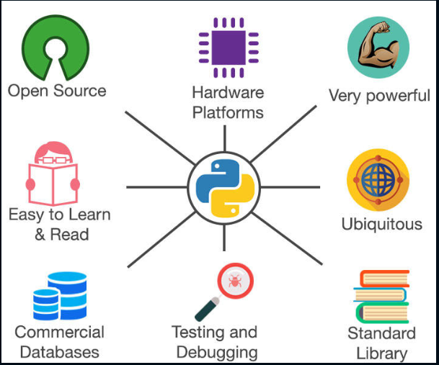

Open Source and Simple to use

Very powerful and Ubiquitous

Supports broad standard library

Supports interactive testing and debugging

Established interface with all major DB's

Runs on variety of hardware platforms

**Technical features of Python**

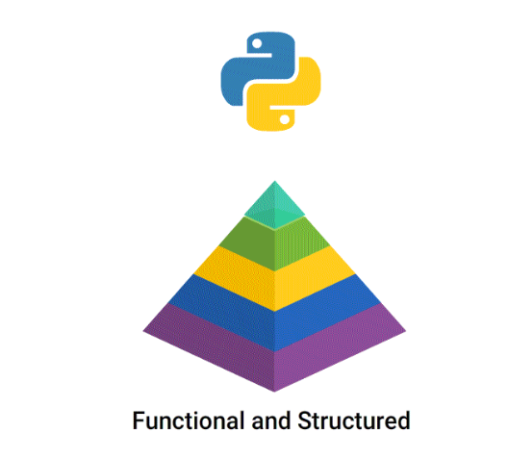

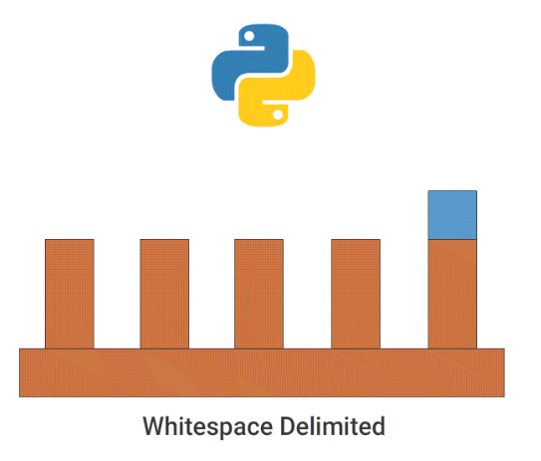

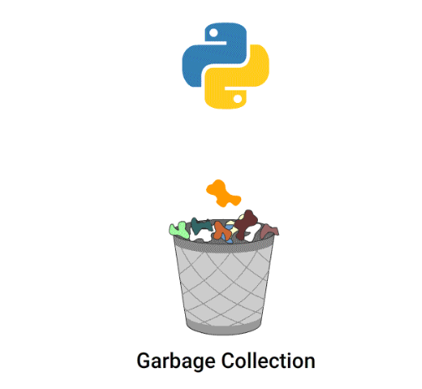

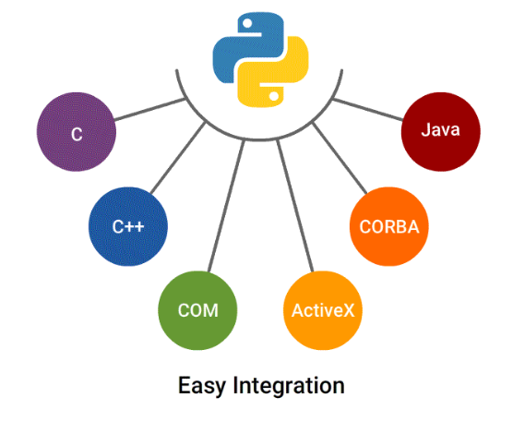

Object-oriented (supports both functional and structured programming)

Dynamically and strongly typed

Whitespace delimited (Indentation)

Scripting language which supports large applications.

High-level dynamic data types and supports dynamic type checking

Automatic garbage collection

Easy integration with C, C++, COM, ActiveX, CORBA and Java.

**Python Implementations**

CPython - Python implementation on standard C language.

Jython - Python implementation with Java virtual machine to blend with Java.

Pypy - Python implemented in Python and its Just-in time compiler making it fastest.

Iron Python - for windows, which implements common runtime libraries to interface with .NET.

**Difference between Python2 & Python3**

**Print**:

* Python 2 treats **“print”** as statement rather a function.
* Python 3 explicitly treats **“print”** as a function.

**Integer Division**:

* Python 2 treats numbers without any digits. (Output of expression 3 / 2 is 1, not 1.5). To get the result 1.5, you would have to write 3.0 / 2.0.
* Python 3 evaluates 3 / 2 as 1.5 by default, which is more intuitive for new programmers.

**List Comprehension Loop Variables**: Common name for the variables that is iterated over in a list comprehension as a global variable get interchanged. This is fixed in Python 3.

**Unicode Strings**: By default Python 3 stores strings as Unicode unlike Python 2.

**Raising Exceptions:** Python 3 requires different syntax for raising exceptions.

* Python 2:raise IOError, “some error message”
* Python3: raise IOError(“some error message”)

